1. Read through the comics below. Think about the concept in evolution that the comic addresses.

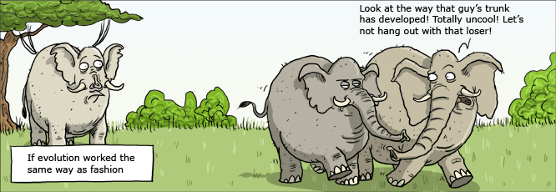

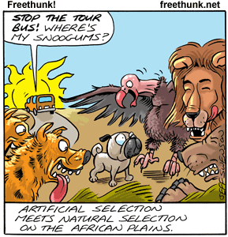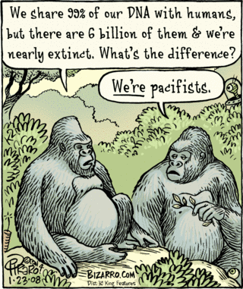

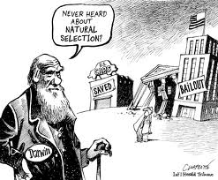 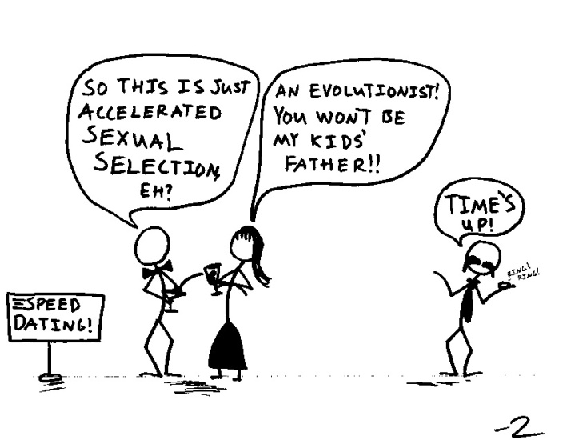

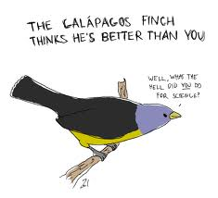

1. Create your own evolution cartoon. You may select a single frame comic or a strip. Your comic can be humorous or poignant or both.
2. What evolution concept does your comic address?