Gel Electrophoresis Activities / Interactions and Heredity
Classwork 15 pts.

Part A: Pearson Lab Bench
http://www.phschool.com/science/biology_place/labbench/lab6/concepts2.html

- Work through the tutorial on Gel Electrophoresis. Read all information, run animations, make notes. Notes should focus on:
- What are restriction enzymes and how do they work?
- What are the steps in a general gel electrophoresis procedure?
- What is the purpose of a ‘marker’ and a standard curve?
- Hind III is a restriction enzyme that is commonly used to cut DNA into marker fragments. How many bands does Hind III cut from the DNA sample?
- Complete the two practice problems.
- Take the 8 question quiz at the end. Record your score _______________.

Part B: Observing the apparatus and loading gels.

- Set the micropipettor for 10 ul. Place a tip on the end of the pipet. Practice loading 10 ul of sample into the wells. Reset and practice loading 20ul.

- 1000ul = 1ml . Use this information to perform the following conversions for micropipette use.

200 ml = ______________ul

1.5 ul = _______________ml

1.5 ml =_____________ul

.76 ml =_____________ul

- Try to load 15 ul of DNA into an actual agarose gel. Troubleshoot the process here. Difficulties? Was it easy? What made it hard to do?

Part C: Reading Gels for Application

- Use the following DNA fingerprint to answer the questions:
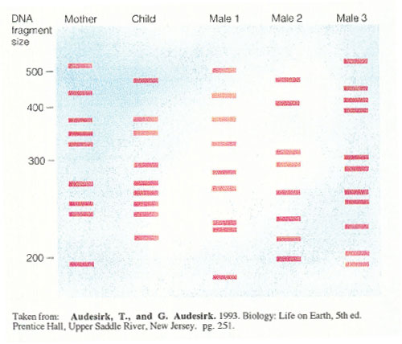

- Which male is the father of the child?
- Give the approximate base pair size of the bands the child received from the mother.
- Give the approximate base pair size of the bands the child received from the father.
- Is every band in the child’s fingerprint accounted for?

- Use this plasmid and the gel below to answer the questions.

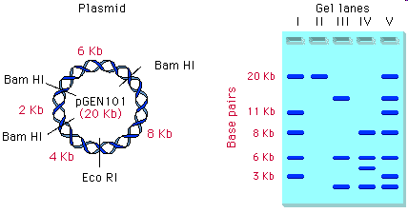
- What is the plasmid made of? Where did it come from?
- What are the notations Bam HI and Eco RI on the plasmid? What will happen at those locations?
- If you mix the plasmid with Bam HI, how many fragments will you have in your tube? What size will each fragment be?
- If you mix the plasmid with the restriction enzyme Hind III, how many fragments will be created? Explain your answer.
- If the plasmid is cut with the noted enzymes and ran on a gel, which lane would represent the plasmid fragments created from a mixture of plasmid and Bam HI? Which lane would represent the plasmid fragments created from a mixture of plasmid DNA and Bam HI AND Eco RI?

