AP Biology: Final Exam Constructed Response.
The Fall 2016 final exam will include THREE of the following constructed response questions in addition to the Multiple Choice.

1. A. Describe the cycling of carbon in the atmosphere. Your description should include how carbon enters that atmosphere and how it is removed.
B. Is the carbon cycle considered a biotic or abiotic cycle? Explain your answer.
C. How has human activity impacted the cycling of carbon in the atmosphere?

2.
Refer to Figure 55.1, a diagram of a food web, for the following questions. (Letters represent species.)

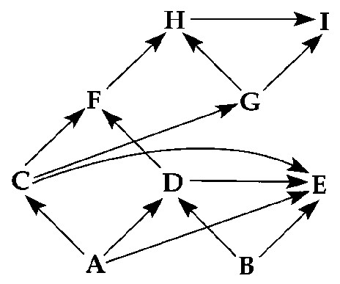

Figure 55.1

A. What term could be used to describe the eating patterns of species E?
B. Predict what would happen if species H were removed from this community?
C. Select a food chain in the food web above and create an energy pyramid labeled with “organisms” from the food web.
D. If this were a terrestrial food web, the combined biomass of C + D would probably be

greater than the biomass of A OR less than the biomass of A + B.

Explain your answer.

3.
- Use this strand to answer the following questions:
5’TACGAAGTTACATTTATC3’

- Is this a strand of DNA or RNA? How do you know?
- Write the complementary strand of DNA. Be sure to label the 5’ and 3’ ends.
- If the original strand is the template strand, what mRNA would be transcribed? Where does this process take place?
- How many codons make up the mRNA strand from this gene?
- Assuming that all mRNA modification was completed. What polypeptide would result from this gene?
- What tRNA anti-codons would bring these amino acids to the ribosome for translation?

- Write the chemical reaction for photosynthesis. Circle reactants and underline products. Explain how the plant gets the reactants needed for photosynthesis. Be sure to include where they come from, plant structures involved and their ultimate location and fate during the process. In lab experiments when the water is labeled with a radioactive isotope of oxygen, scientists find the oxygen gas released as a product is also radioactive. Explain these results.

The results below are measurements of cumulative oxygen consumption by germinating and dry seeds. Gas volume measurements were corrected for changes in temperature and pressure.
Cumulative Oxygen Consumed (mL)
Time (minutes) | 0 | 10 | 20 | 30 | 40
22 C Germinating Seeds | 0.0 | 8.8 | 16.0 | 23.7 | 32..0
Dry Seeds | 0.0 | 0.2 | 0.1 | 0.0 | 0.1
10 C Germinating Seeds | 0.0 | 2.9 | 6.2 | 9.4 | 12.5
Dry Seeds | 0.0 | 0.0 | 0.2 | 0.1 | 0.2
    - What cellular process is being measured in these seeds? Write the equation for that process.
    - Which seeds had the highest rate of oxygen consumption? Why is this so?
    - When setting up this experiment to measure oxygen gas, KOH was used. Why?
    - If similar data was collected on the output of carbon dioxide, how would it relate to this data?

Use the following information to answer the questions below.

A eukaryotic gene has "sticky ends" produced by the restriction endonuclease EcoRI. The gene is added to a mixture containing EcoRI and a bacterial plasmid that carries two genes conferring resistance to ampicillin and tetracycline. The plasmid has one recognition site for EcoRI located in the tetracycline resistance gene. This mixture is incubated for several hours, exposed to DNA ligase, and then added to bacteria growing in nutrient broth. The bacteria are allowed to grow overnight and are streaked on a plate using a technique that produces isolated colonies that are clones of the original. Samples of these colonies are then grown in four different media: nutrient broth plus ampicillin, nutrient broth plus tetracycline, nutrient broth plus ampicillin and tetracycline, and nutrient broth without antibiotics.

- Bacteria containing a plasmid into which the eukaryotic gene has integrated would grow in:

Nutrient Broth Only OR Ampicillin and Nutrient Broth

Explain your answer.

- Bacteria that do not take up any plasmids would grow on which media?

Nutrient Broth Only OR All broths on all four plates

Explain your answer

7.
Create a cladogram using the animal data:
Derived Characteristic | Lamprey | Antelope | Bald Eagle | Alligator | Sea Bass
Lungs |  | X | X | X
Jaws |  | X | X | X | X
Feathers |  |  | X
Notochord | X | X | X | X | X
Gizzard |  |  | X | X
Hair |  | X

Create a cladogram that shows the evolutionary history of the four major groups of plants AND a common ancestor. Each clade should be divided by a derived characteristic.

8.

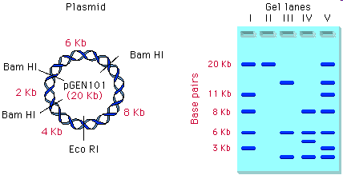
- Define Restriction Enzyme.
- Define Plasmid
- The plasmid above shows cuts based on recognition sites for two different enzymes. The plasmid DNA is restricted and processed through gel electrophoresis. The results are shown above. Which lane in the gel contains the sample of DNA that was cut using Eco RI? Explain.
- Which lane in the gel contains the sample of DNA that was cut using Bam HI? What are the sizes of the bands produced?
- Describe the process scientists would use to create recombinant DNA using this plasmid. Make sure to include the following terms: restriction enzyme, origin of replication, donor gene, sticky ends, ligase

9.
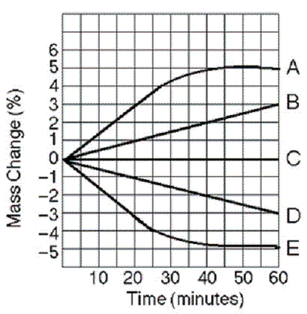
Five cells (A-E) of various NaCl concentrations were placed in beakers containing 0.6 M NaCl solution.
a. Which cell has a water potential equal to the water potential of the 0.6M solution in the beaker? Explain how you know.
b. Which cell(s) was in a hypertonic environment when initially placed in the beaker? Explain how you know.
c. Which cell(s) was in a hypotonic environment when initially placed in the beaker? Explain how you know.
d. Calculate the solute potential of the initial beakers if the experiment was conducted at 22 degrees Celsius. Show your work.

10.
For the following questions, match the labeled component of the cell membrane (Figure 7.1) with its description. Give the function when requested.

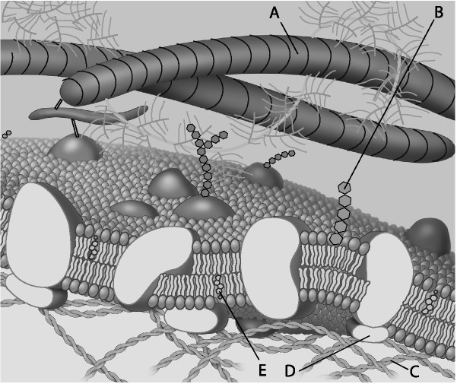

Figure 7.1

peripheral protein

filament of the cytoskeleton

cholesterol molecule - give function

glycolipid - give function

fiber of the extracellular matrix
11. Explain how chemiosmosis produces ATP and the role it plays in either photosynthesis OR respiration.

12. Discuss the role of photosynthesis AND cellular respiration in carbon cycling in the biosphere.

13. Charles Darwin proposed that evolution by natural selection was the basis for the difference that he saw in similar organisms as he traveled and collected specimen in South America and on the Galapagos Islands.

a. Explain the theory of evolution by natural selection as presented by Darwin. (5)

b. Each of the following relates to an aspect of evolution. Explain two of the following in terms of natural selection.(5)
i. insecticide resistant insects or antibiotic
resistant bacteria.
ii. speciation and isolation
iii. behavior (imprinting, social behaviors, habituation), etc.
iv. heterozygote advantage

