**Unit 3 Related FRQ – Cells**

FRQ #1

Describe the similarities and differences between the biochemical pathways of aerobic respiration and photosynthesis in eukaryotic cells. Include in your discussion the major reactions, the end products, and energy transfers.

FRQ #2

The rate of photosynthesis may vary with changes that occur in environmental temperature, wavelength of light, and light intensity. Using a photosynthetic organism of your choice, choose only ONE of the three variables (temperature, wavelength of light, or light intensity) and for this variable

* + **design** a scientific experiment to determine the effect of the variable on the rate of photosynthesis for the organism;
  + **explain** how you would measure the rate of photosynthesis in your experiment;
  + **describe** the results you would expect. **Explain** why you would expect these results.

FRQ #3

Describe the light reactions of photosynthesis and, for both a C3 and a C4 plant, trace the path of a carbon dioxide molecule from the point at which it enters a plant to its incorporation into a glucose molecule. Include leaf anatomy and biochemical pathways in your discussion of each type of plant.

FRQ #4

Explain what occurs during the Krebs (citric acid) cycle and electron transport by describing the following:

* 1. The location of the Krebs cycle and electron transport chain in mitochondria.
  2. The cyclic nature of the reactions in the Krebs cycle.
  3. The production of ATP and reduced coenzymes during the cycle.
  4. The chemiosmotic production of ATP during electron transport.

FRQ #5

Write the chemical reaction for photosynthesis. Circle reactants and underline products. Explain how the plant gets the reactants needed for photosynthesis. Be sure to include where they come from, plant structures involved and their ultimate location and fate during the process. In lab experiments when the water is labeled with a radioactive isotope of oxygen, scientists find the oxygen gas released as a product is also radioactive. Explain these results.

FRQ #6

|  |  |  |  |  |  |
| --- | --- | --- | --- | --- | --- |
| The results below are measurements of cumulative oxygen consumption by germinating and dry seeds. Gas volume measurements were corrected for changes in temperature and pressure.  Cumulative Oxygen Consumed (mL) | | | | | |
| Time (minutes) | 0 | 10 | 20 | 30 | 40 |
| 22 C Germinating Seeds | 0.0 | 8.8 | 16.0 | 23.7 | 32..0 |
| Dry Seeds | 0.0 | 0.2 | 0.1 | 0.0 | 0.1 |
| 10 C Germinating Seeds | 0.0 | 2.9 | 6.2 | 9.4 | 12.5 |
| Dry Seeds | 0.0 | 0.0 | 0.2 | 0.1 | 0.2 |

* + - What cellular process is being measured in these seeds? Write the equation for that process.
    - Which seeds had the highest rate of oxygen consumption? Why is this so?
    - When setting up this experiment to measure oxygen gas, KOH was used. Why?
    - If similar data was collected on the output of carbon dioxide, how would it relate to this data?

FRQ #7

Explain how chemiosmosis produces ATP and the role it plays in either photosynthesis OR respiration.

FRQ #8

*For the following questions, match the labeled component of the cell membrane (Figure 7.1) with its description. Give the function when requested.*

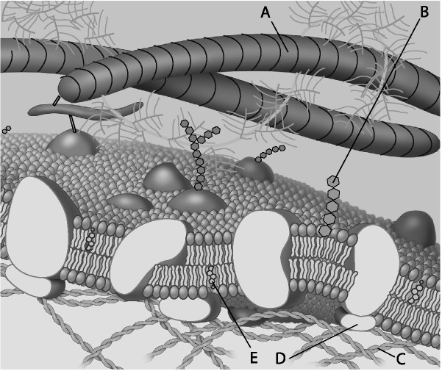

**Figure 7.1**

**peripheral protein**

**filament of the cytoskeleton**

**cholesterol molecule - give function**

**glycolipid - give function**

**fiber of the extracellular matrix**

FRQ #9

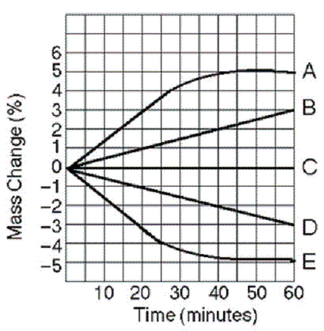

Five cells (A-E) of various NaCl concentrations were placed in beakers containing 0.6 M NaCl solution.

a. Which cell has a water potential equal to the water potential of the 0.6M solution in the beaker? Explain how you know.

b. Which cell(s) was in a hypertonic environment when initially placed in the beaker? Explain how you know.

c. Which cell(s) was in a hypotonic environment when initially placed in the beaker? Explain how you know.

d. Calculate the solute potential of the initial beakers if the experiment was conducted at 22 degrees Celsius. Show your work.

FRQ #10



The figure above represents a generalized hormone-signaling pathway. Briefly explain the role of each

numbered step in regulating target gene expression.

FRQ #11

1. Identify FOUR organelles that should be present in the eukaryotic organism and describe the function of each organelle.
2. Prokaryotic cells lack membrane-bound organelles found in eukaryotes. However, prokaryotes must perform many of the same functions as eukaryotes. For THREE of the organelles identified in part (a), explain how prokaryotic cells carry out the associated functions.
3. According to the endosymbiotic theory, some organelles are believed to have evolved through a symbiotic relationship between eukaryotic and prokaryotic cells. Describe TWO observations/pieces of evidence that support the endosymbiotic theory.

FRQ #12

The following experiment was designed to test whether different concentration gradients affect the rate of diffusion. In this experiment, four solutions (0% NaCl, 1% NaCl, 5% NaCl , and 10% NaCl) were tested under identical conditions. Fifteen milliliters (mL) of 0% NaCl were put into a bag formed of dialysis tubing that is permeable to Na+ , Cl- , and water. The same was done for each NaCl solution. Each bag was submerged in a separate beaker containing 300 mL of distilled water. The concentration of NaCl in mg/L in the water outside each bag was measured at 40-second intervals. The results from the 5% bag are shown in the table below.

|  |  |
| --- | --- |
| **Time (seconds)** | **NaCl (mg/L)** |
| 0 | 0 |
| 40 | 130 |
| 80 | 220 |
| 120 | 320 |
| 160 | 400 |

(a) On the axes provided, graph the data for the 5% NaCl solution.

(b) Using the same set of axes, draw and label three additional lines representing the results that you would predict for the 0% NaCl, 1% NaCl, and 10% NaCl solutions. Explain your predictions.

(c) Farmlands located near coastal regions are being threatened by encroaching seawater seeping into the soil. In terms of water movement into or out of plant cells, explain why seawater could decrease crop production. Include a discussion of water potential in your answer.