History of Life Webquest
First Organic Molecules: http://www.windows2universe.org/earth/Life/miller_urey.html
The Miller-Urey Experiment
- What was the purpose of their experiment?

- What did they find in the liquid pool?

- Their experiment lends support for what theory?

Miller -Urey Experiment Virtual Lab OR Video
Virtual Lab: https://www.wiley.com/college/trefil/0470118547/vdl/lab_miller_experiment/ (needs flash)
Video: https://www.youtube.com/watch?v=iahBQolXQH8
Miller-Urey Experiment Animation: Use the video to answer the following:
https://www.youtube.com/watch?v=UyzScxiGK20
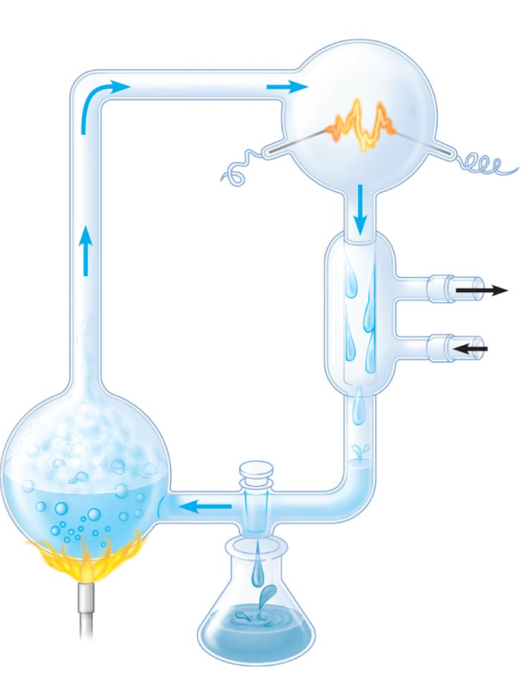
- The early atmosphere contained what gases?

- On the diagram to the right, label the water reservoir, electrodes and condenser.

- Put a star where they added the gases present in the early Earth.
- Why was the water heated?

- What did the electric sparks mimic?
- What did formaldehyde and hydrogen cyanide combine to form?

- What did their experiments show? IMPORTANT!

Power Behind Primordial Soup Discovered
Read the ScienceDaily article https://www.sciencedaily.com/releases/2013/04/130404122234.htm (or printed)

Answer the following analysis questions:
- Chemiosmosis is a process that drives the creation of ATP. This process requires the use of specific enzymes which were unlikely to have existed on early Earth.
- What has this new study uncovered in relation to ATP on early Earth?

- How do scientists postulate that the phosphorus on early Earth was created?

- The scientists in this study attempted to simulate the conditions created from meteorites impacting Earth. In order to do so, they had to implement proper experimental design.
- Scientific experiments strive to be accurate. Accuracy refers to results that are correct. How can accuracy be achieved?

- Reliability refers to an experiment that can be duplicated over and over again with the same results. Give an example of how reliability can be achieved.

- Experiments usually have several controlled variables. These are variables that must be kept constant in all parts of an experiment. For examples, if an experiment is testing the effect of sunlight on the growth rate of 5 seeds, the only variable that should change should be the amount of sunlight. All other variables should remain the same to ensure that sunlight is the only aspect affecting the results. The other variables, such as soil type, water, type of fertilizer are the controlled variables. Looking back at the simulation experiment on the meteorite, describe two variables that should have been controlled.
Final Application: Using this information and research on your own, complete the chart for the different theories associated with the origin of life:

